Project Explanations

Project 1:

Objective:
The purpose of this project is to measure current between two resistors and voltage across each resistor using Proteus simulation.

Components Used:
- AC Voltage Source (5V)
- Resistors:
  - R1 = 5.1kΩ
  - R2 = 3.3kΩ
- Ammeter
- Voltmeter
- Ground

Steps to Create Circuit in Proteus:
- Open Proteus software and click on New Project.
- Enter project name and proceed with default settings.
- Click on Pick Devices (P) button.
- Search and select the following components:
  - Resistor
  - AC Voltage Source
  - Ammeter
  - Voltmeter
  - Ground
- Place all components on the workspace.
- Set resistor values:
  - R1 = 5.1kΩ
  - R2 = 3.3kΩ
- Set AC source voltage to 5V.
- Connect the circuit in series using wires.
- Place the ammeter in series between R1 and R2.
- Connect the voltmeter in parallel across each resistor to measure voltage.
- Connect the ground terminal properly.
- Run the simulation and observe readings.

Calculations:
Total Resistance:
R_total = R1 + R2
R_total = 5.1kΩ + 3.3kΩ = 8.4kΩ
Current (Ohm’s Law):
I = V / R
I = 5V / 8.4kΩ = 0.595 mA (approx)

Voltage across Resistors:
V1 = I × R1
V1 = 0.595mA × 5.1kΩ ≈ 3.03V
V2 = I × R2
V2 = 0.595mA × 3.3kΩ ≈ 1.96V
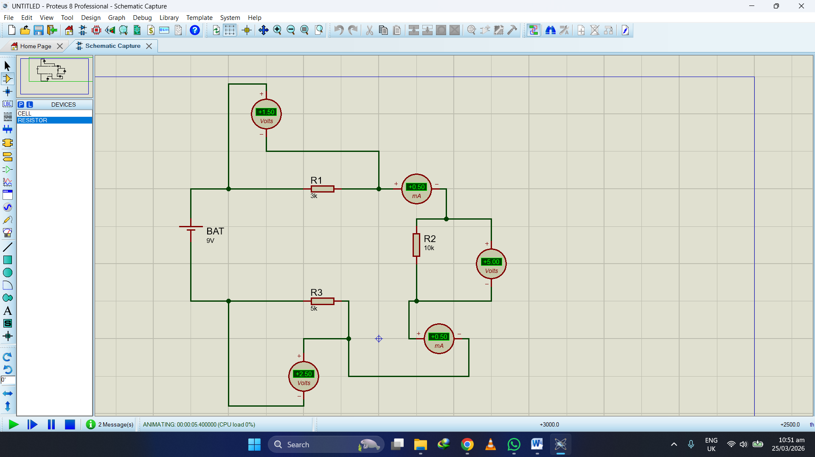

Project 2:

Objective:
The purpose of this project is to design a simple series circuit and calculate current and voltage across each resistor.

Components Used:
- DC Battery (9V)
- Resistors:
  - R1 = 3kΩ
  - R2 = 10kΩ
  - R3 = 5kΩ
- Connecting wires

Steps to Create Circuit in Proteus:
- Open Proteus and create a New Project.
- Enter project details and continue with default options.
- Click on Pick Devices (P).
- Search and select:
  - Resistor
  - DC Battery
- Place components on the workspace.
- Set resistor values:
  - R1 = 3kΩ
  - R2 = 10kΩ
  - R3 = 5kΩ
- Set battery voltage to 9V.
- Connect all components in series (end-to-end) using wires.
- Check proper polarity of battery.
- Run simulation to verify circuit.

Calculations:
Total Resistance:
R_total = R1 + R2 + R3
R_total = 3kΩ + 10kΩ + 5kΩ = 18kΩ
Current (Ohm’s Law):
I = V / R
I = 9V / 18kΩ = 0.5 mA

Voltage across each resistor:
V1 = I × R1 = 0.5mA × 3kΩ = 1.5V
V2 = I × R2 = 0.5mA × 10kΩ = 5V
V3 = I × R3 = 0.5mA × 5kΩ = 2.5V